Stocked Boxes – Manufactured for resale to multiple end users.

- Create an estimate for the stock item with your company name (box plant ABC) as the customer. Key in the FG Item number that you want to use, such as 12x12x12 or BAKERY-6-INCH.

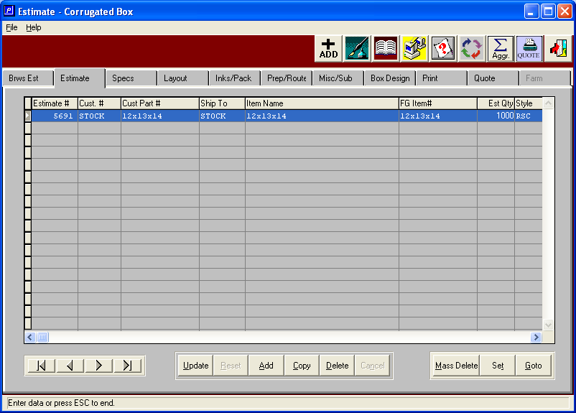

2. Go to the inventory file (IF1) and look up the Finished Goods record for the stock item that was created when you built the estimate. Now go the “Totals / CP#” (Customer Part #) tab and put the unique part number that each of your customers might give to this item. Also, be certain that the item is “stocked” on the view item tab .

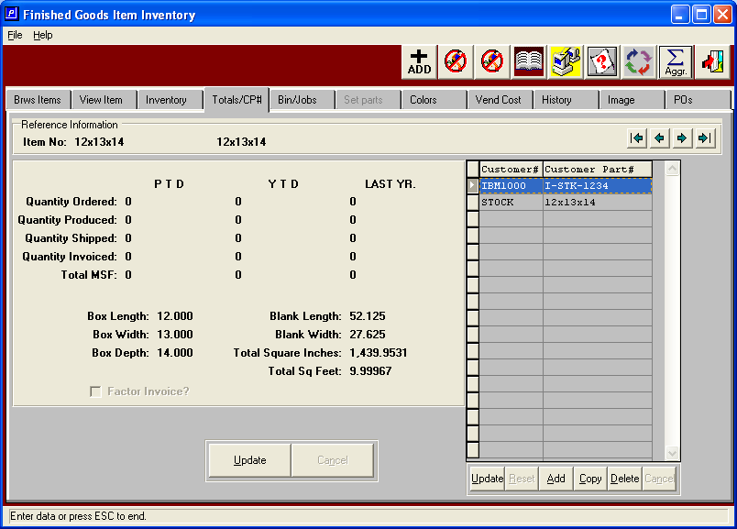

3. You can now build unique quantity sensitive prices for this item, by customer, in the Price Matrix File. (O-F-3). Please note that the item number is FG # that you keyed into the estimate – which is your in-house number. When the system looks for a price at order entry it will first look to see if there is customer specific price for that item (or for what the customer called this item on the Customer Part Number tab in the inventory file). If there is not a customer specific price it will see if there is a price for the “Customer Type” – for example, if all of your brokers had a customer type in the customer file of “Broker” then you could build a single price list for all brokers (rather than having multiple customer specific price lists for each ‘broker” customer). If the system does not see a unique customer or customer type price list it will use a price for the item number only. Also please note that you could use this file to establish a discount from a price list for a specific customer.

